Independent-Samples t-Test – Example 1 (Statistics Learning) – Answer Key

I predict that students who learn to calculate statistics by hand are better able to select the appropriate statistical test to use than students who learn to calculate statistics using SPSS. After teaching students using these two methods, I obtained the quiz scores below.

Step 1. State your hypotheses.
a. Is it a one-tailed or two-tailed test?
One-tailed
b. Research hypotheses
H_{A}: Students who calculate statistics by hand are better able to select the appropriate statistical test to use than students who calculate statistics using SPSS.

H₀: Students who calculate statistics by hand do not differ from or are less able to select the appropriate statistical test than students who calculate stats using SPSS.

c. Statistical hypotheses
H_{A}: μ_{hand} - μ _{SPSS} > 0

H₀: μ_{hand} - μ _{SPSS} < 0

Step 2. Set the significance level ➔ α = .05 Determine t_{crit}. t_{crit} = +1.860

Step 3. Compute the appropriate statistical test.

SS₁ = 5.2 SS₂ = 5.2
Hand-Calculation Scores  (X₁) |  | X – | (X –)²
8 | 8.4 | -0.4 | 0.16
7 |  | -1.4 | 1.96
10 |  | 1.6 | 2.56
9 |  | 0.6 | 0.36
8 |  | -0.4 | 0.16
ΣX = 42 |  |  | SS = Σ(X –)² = 5.2
= 8.4

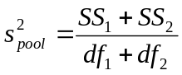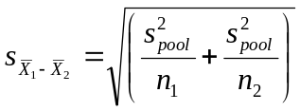

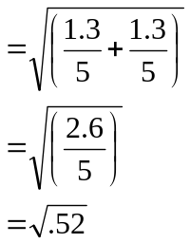
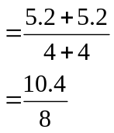

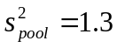

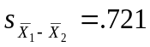
SPSS Scores  (X₂) |  | X – | (X –)²
6 | 6.4 | -0.4 | 0.16
5 |  | -1.4 | 1.96
7 |  | 0.6 | 0.36
8 |  | 1.6 | 2.36
6 |  | -0.4 | 0.16
ΣX₂ = 32 |  |  | SS = Σ(X –)² = 5.2
= 6.4

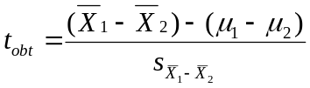

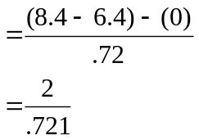

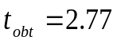

Step 4. Make a decision. Determine whether the value of the test statistic is in the critical region.
Draw a picture.
Is t_{obt} in the critical region? yes
Should you reject or retain the H₀? reject t_{obt} = 2.77

t_{crit} = +1.860

Step 5. Report the statistical results.
t(8) = 2.77, p < .05

Step 6. Write a conclusion.
Students who calculate statistics by hand (M = 8.4) are significantly better at selecting the appropriate statistical test to use than students who calculate statistics using SPSS (M = 6.4), t(8) = 2.77, p < .05.

Step 7. Compute the estimated d.
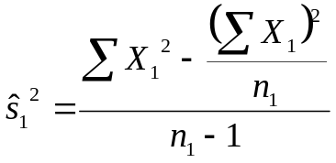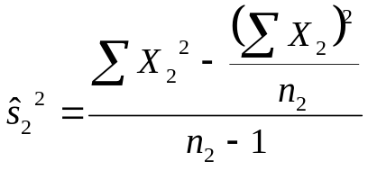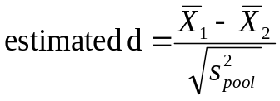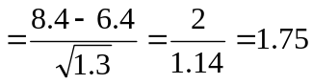
d Effect Size
0.2 Small effect
0.5 Medium effect
0.8 Large effect

Step 8. Compute r² and write a conclusion.

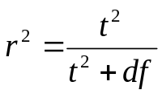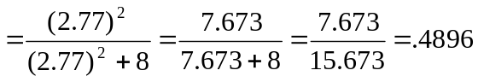 r2 Percentage of Variance Explained
0.01 Small effect
0.09 Medium effect
0.25 Large effect

The method by which students learn statistics can account for 48.96% of the variability in students’ ability to select the appropriate statistical test.

